LINEAR REGRESSION MODELING OF GROSS CALORIFIC VALUE BASED ON TOTAL MOISTURE AND ASH CONTENT IN COAL BLENDS

Taufik Arief¹*, A. M. Jannah². B. Cahyaningsih³, Aisyah Minzikrina M.Rus⁴.
Universitas Sriwijaya
E-mail: arieftaufik901@gmail.com, muthiaarridha@gmail.com, bimbicahyaningsih@ft.unsri.ac.id, aisyahminzikrina@ft.unsri.ac.id.

Received : 20 March 2026 Accepted : 17 April 2026
Revised : 30 March 2026 Published : 27 April 2026

Abstract
Coal blending in stockpile management is widely implemented to meet market quality specifications; however, variations in coal quality parameters may significantly influence the gross calorific value (GCV). This study develops a linear regression-based predictive model to quantify the decline in GCV as a function of total moisture (TM) and ash content (AC) in multi-brand coal blending. A dataset derived from three mine-brand coals (MT-49, BB-51, and BTB-47) was used as a case study. GCV (ar) was treated as the dependent variable, while TM (ar) and AC (ar) were considered independent variables. The regression results reveal a strong negative linear relationship between TM and GCV, with a coefficient of determination (R²) of 0.6303, indicating that 63.03% of GCV variability is explained by changes in total moisture. In contrast, ash content shows a weaker relationship with GCV, with an R² of 0.1974 (19.74%). Quantitatively, an increase in TM by 1%, 2%, and 3% reduces GCV by 104.82, 209.64, and 314.46 kcal/kg (ar), respectively. Similarly, an increase in AC by 1%, 2%, and 3% decreases GCV by 94.60, 189.20, and 283.80 kcal/kg (ar), respectively. Blending simulations representing worst-case, moderate-case, and best-case scenarios were performed using the developed regression model to evaluate their impact on final calorific value (GCV). The moderate-case and best-case scenarios achieved the target specifications, confirming that moisture control plays a critical role in maintaining calorific value during coal stock blending. These findings demonstrate that a simple regression-based approach can serve as an effective decision-support tool for coal quality control and operational blending optimization.

Keywords: Coal Blending, Stockpile Management, Gross Calorific Value, Total Moisture, Ash Content, Linear Regression

INTRODUCTION
Batubara remains one of the primary energy resources in many countries, including Indonesia, playing a crucial role in meeting domestic energy demand and supporting export-oriented industries. The economic value of coal is strongly determined by its quality parameters, among which the gross calorific value (GCV) is the most critical indicator used in commercial transactions. Variations in coal quality frequently occur due to the heterogeneous nature of coal formation processes, even within the same seam, leading to fluctuations in calorific value that may affect product consistency and contractual compliance [1]. Among coal quality parameters, total moisture (TM) and ash content (AC) are widely recognized as dominant factors influencing GCV. Higher moisture content reduces the effective heating value due to energy losses during water evaporation, while increased ash content represents non-combustible material that lowers the net energy yield. These parameters are commonly determined through proximate analysis and are routinely used for coal quality evaluation. However, despite their importance, the quantitative relationship between TM, AC, and GCV is often treated descriptively rather than being incorporated into predictive models that can support operational decision-making [2,3] .Coal blending is widely applied to manage coal quality variability by combining coals with different characteristics to achieve target specifications. In practice, blending decisions are frequently based on empirical experience or simple averaging approaches, which may not adequately capture the combined effects of multiple quality parameters on GCV. Previous studies have discussed coal blending strategies and quality control; however, limited attention has been given to the development of simple, data-driven predictive models that explicitly quantify the influence of TM and AC on GCV for blending optimization [4,5,6]. This study addresses this gap by developing a linear regression-based model to predict coal GCV using total moisture and ash content as independent variables. The model is applied to evaluate blending scenarios and to demonstrate its potential use as a practical decision-support tool for coal quality control. The contribution of this research lies in providing a straightforward and operationally applicable predictive framework that links routine laboratory quality data to GCV estimation, thereby supporting more reliable coal blending planning. The objective of this study is to analyze the influence of total moisture and ash content on gross calorific value and to develop a regression-based prediction model that can be utilized in coal blending applications.

METHOD
Research Design and Methodologichal Framework
The research design was conducted through three main stages: field survey, sampling, and calculation and linear regression modeling to predict coal GCV using total moisture content and ash content as independent variables. This model was applied to evaluate blending scenarios and to demonstrate its potential use as a practical decision support tool for coal quality control. The contribution of this study lies in providing a clear and operationally applicable predictive framework that links routine laboratory quality data with GCV estimates, thus supporting more reliable coal blending planning. A schematic illustration is shown in Figure 1. The specific sequence can be seen in Figure 2
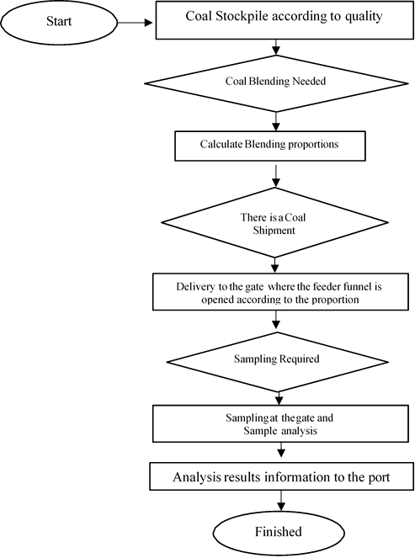
Figure 1. Coal Blending Market Brand

Study Area and Data Collection
This study employed a quantitative research approach utilizing primary and secondary data. The dataset was obtained from routine coal quality monitoring conducted at large-scale coal mining operations in Indonesia. Primary data consisted of the results of three mined coal brands (MT-49, BB-51, and BTB-47), including total moisture content (TM), ash content (AC), and gross calorific value (GCV). Secondary data included market coal specifications, blending plans, and quality monitoring records used to support blending scenario evaluations. The Market Brand BA-48 specification data is based on the directional decision regarding changes to the trademark (brand) and coal specifications of PT. Bukit Asam Tbk in 2022. Coal quality parameters including ash content, total moisture content, and gross calorific value are presented in detail in Table 1.

Table 1. Market Brand BA-48 Specifications
Kualitas Batubara | Simbol | Satuan | Nilai Rentang Nilai  (%) Tipikal
Ash Content | AC | % ar | 6 s/d 9 8
Total Moisture | TM | % ar | 27 s/d 32 30
Gross Calorific Value | GCV | kcal/kg-ar | 4.701 s/d 4.900 4800

Table 2 TM, AC, and GCV Range Values of Mine Brand
Mine Brand | Data | TM  (% ar) | AC  (% ar) | GCV  (kcal/kg ar)
MT-49 | 62 | 26,00-31,80 | 1,17-6,51 | 4.400-5.141
BB-51 | 42 | 24,80-30,50 | 1,89-8,18 | 4.715-5.496
BTB-47 | 45 | 28,30-34,50 | 1,34-10,47 | 4.414-5.087
The range of coal quality values for the mined coal brands in Figure 2 shows that the dataset, derived from three mined coal brands (MT-49, BB-51, and BTB-47), was used as a case study. GCV (ar) was treated as the dependent variable, while TM (ar) and AC (ar) were considered independent variables.
The field observation survey period was conducted from February to April 2025, during which representative coal quality data were collected for model development and analysis.
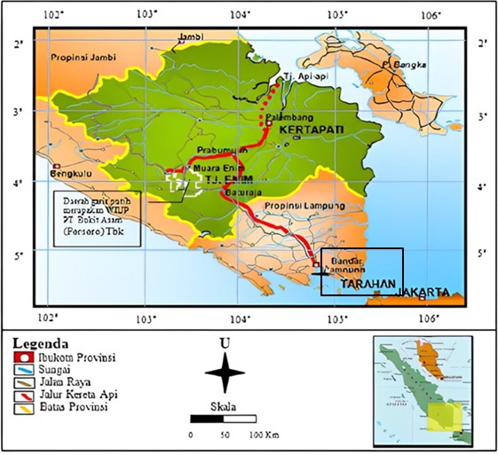
Figure 2. Coal blending observation location at Tarahan Port Stockpile PT. Bukit Asam, Tbk

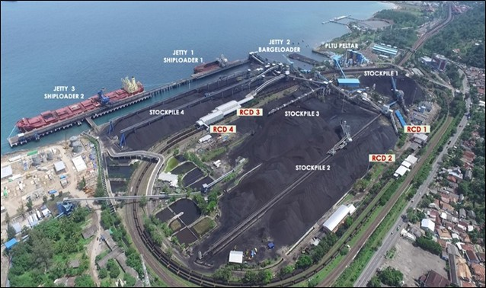
Figure 3. PT Bukit Asam Tbk Tarahan Port Unit

Variables and Data Description
In this study, gross calorific value (GCV) was defined as the dependent variable (Y), while total moisture (TM) and ash content (AC) were selected as independent variables (X₁ and X₂). These variables were chosen due to their dominant influence on coal calorific value and their availability from routine laboratory testing. All quality parameters were expressed on an as-received (ar) basis to reflect actual operational conditions.

Linear Regression Model Development
A multiple linear regression model was developed to quantify the relationship between GCV, total moisture, and ash content. The regression analysis was conducted using the Ordinary Least Squares (OLS) method. The general form of the regression model is expressed as follows:
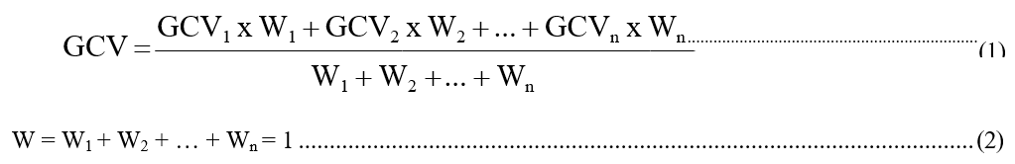
where:
GCV = gross calorific value (kcal/kg, ar)
TM = total moisture (% ar)
AC = ash content (% ar)
β₀ = regression intercept
β₁, β₂ = regression coefficients
ε = error term
The selection of a linear regression model was based on preliminary data exploration and findings from previous studies that reported approximately linear relationships between GCV and coal quality parameters within operational ranges.

Model Validation and Statistical Analysis
To evaluate the reliability of the regression model, statistical indicators including the coefficient of determination (R²), regression coefficients, and significance levels (p-values) were analyzed. These indicators were used to assess the explanatory power of the model and the contribution of each independent variable to GCV variation. All regression analyses were performed using Microsoft Excel.

Application of the Model for Blending Scenario Analysis
The developed regression model was subsequently applied to evaluate coal blending scenarios. Based on the predicted GCV values, three blending conditions—worst-case, moderate-case, and best-case—were defined to represent different combinations of mine-brand coal proportions. The blending scenarios were assessed by comparing the predicted GCV values
with the target specification. This approach demonstrates the practical applicability of the regression model as a decision-support tool for coal blending planning.

RESULTS AND DISCUSSION
Effect of Ash Content on Gross Calorific Value
Based on the graph above, the linear regression analysis yields the following equation:
Y = -94.6x + 5130.4
Where Y is the GCV value, and X is the AC value. The -94.6 in this equation represents the slope, indicating that every 1% increase in AC will result in a decrease in the GCV of 94.6 kcal/kg ar. The 5130.4 is the intercept (constant), which represents the theoretical GCV value when AC is 0. The coefficient of determination (R2) is 0.1974, indicating that the contribution of ash content (AC), the independent variable (X-axis), to the decrease in GCV, the dependent variable (Y-axis), is 0.1974, or 19.74%. The remaining 80.26% is influenced by other coal quality parameters outside this regression model.
The Data distribution in Figure 4 shows that most samples are relatively homogeneous, as seen from the points that are close together in some areas. However, there are also points in other areas that are more widely distributed. This is because the number of samples in these areas is much smaller, so the Data points appear separated or spread out due to the greater variation in AC. and GCV values, namely, the AC value range between 1% ar and 10% ar and GCV values between 4400 kcal/kg AR and 5500 kcal/kg AR. The graph also shows that the regression line has a negative slope or a downward trend, indicating a negative (inverse) relationship between AC and GCV. This means that an increase in ash content (AC) results in a decrease in gross calorific value (GCV). This study simulated the increase in the average AC value of MT-49, BB-51, and BTB-47 blending products, using worst-case, moderate-case, and best-case blending conditions of 1%, 2%, and 3%, respectively. These conditions served as independent variables (X) in the calculation using the equation y = -94.6x + 5130.4. The results were as follows:
- A 1% increase in AC resulted in a decrease in the GCV value of 94.60 kcal/kg.
- A 2% increase in AC resulted in a decrease in the GCV value of 189.20 kcal/kg.
- A 3% increase in AC resulted in a decrease in the GCV value of 283.80 kcal/kg. Effect of Ash Content on GCV
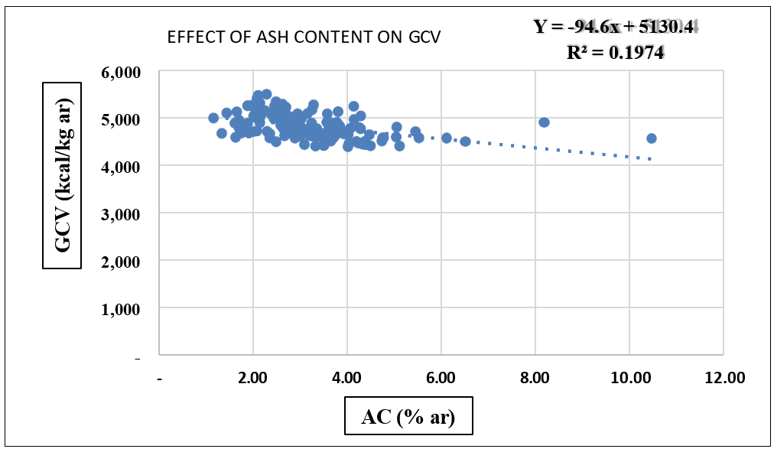
Figure 4. Effect of Increasing AC on Decreasing GCV

Effect of Total Moisture on Gross Calorific Value
Linear regression analysis revealed a clear negative relationship between total moisture content (TM) and gross calorific value (GCV), as shown in Figure 5. The resulting regression equation is:
y = -104.82x + 7901.5
Where Y is the GCV value and X is the TM value. The -104.82 in the equation represents the slope, indicating that every 1% increase in TM results in a decrease in GCV of 104.82 kcal/kg. 7901.5 is the intercept (constant), which represents the theoretical value of GCV when TM is 0. The coefficient of determination (R2) is 0.6303, indicating that the contribution of total moisture content (TM) as the independent variable (X-axis) to the decrease in gross calorific value (GCV) as the dependent variable (Y-axis) is 0.6303, or 63.03%. Meanwhile, the remaining 36.97% is influenced by other coal quality parameter variables outside this regression model.
The data distribution in the graph shows that most samples are relatively homogeneous, as seen from adjacent points, and have a range of TM values between 25% ar and 35% ar and GCV values between 4400 kcal/kg ar and 5500 kcal/kg ar. The graph also shows that the regression line has a negative slope or a downward trend, indicating a negative (inverse) relationship between TM and GCV. This means that an increase in total moisture (TM) results in a decrease in gross calorific value (GCV).
This study simulated the increase in the average TM value from blending MT-49, BB-51, and BTB-47 using worst-case, moderate-case, and best-case blending conditions of 1%, 2%, and 3%, respectively. These variables served as independent variables (X) in the calculation using the equation y = -104.82x + 7901.5. To determine their effect on the decrease in the average GCV value from blending MT-49, BB-51, and BTB-47, the following equations were used:
- A 1% increase in TM resulted in a decrease of 104.82 kcal/kg in the GCV value.
- A 2% increase in TM resulted in a decrease of 209.64 kcal/kg in the GCV value.
- A 3% increase in TM resulted in a decrease of 314.46 kcal/kg in the GCV value.
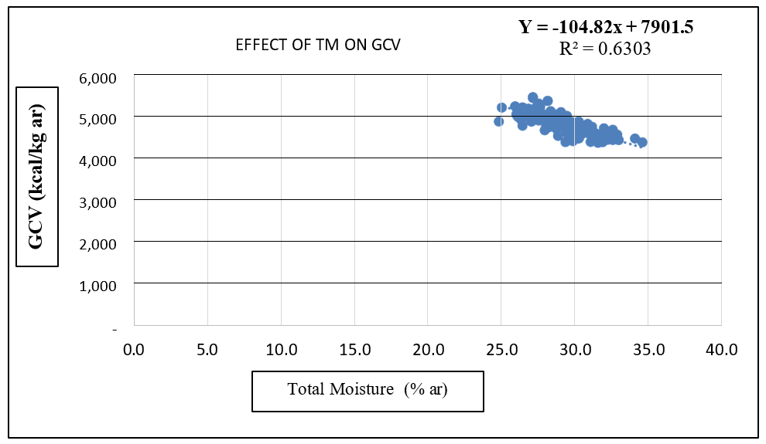
Figure 5. Effect of Increasing TM on Decreasing GCV

Implications of Regression Results for Blending Scenarios
Three blending scenarios—worst-case, moderate, and best-case—were assessed using the generated equations in order to actually illustrate the regression model. These scenarios show varying coal usage techniques and rising tolerance levels for quality problems. There is little tolerance for increases in TM and AC in the worst-case situation. The GCV falls below the BA-48 standard even with a 1% increase in either parameter, suggesting a substantial possibility of price modifications or fines. This situation demonstrates how marginal blending designs are susceptible to variations in quality. A balanced blending approach is represented by the moderate scenario, which permits a 1% increase in TM or AC while keeping GCV within the goal specification range. From a technical and financial standpoint, this blending configuration is the most effective since it strikes the ideal balance between the use of coal quality and operational flexibility. The best-case scenario permits up to a 2% rise in TM and AC without going against the GCV specification, providing the largest tolerance for quality variations. Nevertheless, increased use of high-calorie coal results from this resilience, which may lessen total resource optimization. These findings show that the most economically advantageous mixing strategy is not always the most technically safe.

Analysis Particle Size Distribution
PSD analysis results indicate that variations in particle size distribution significantly influence coal blending characteristics. Samples with finer distributions (Samples 2 and 5) show potential for increased combustion efficiency due to their larger surface area, while samples with coarser distributions (Sample 3) tend to decrease blend homogeneity and increase the risk of segregation and incomplete combustion. The shape of the PSD curve in the five samples shows a relatively consistent tendency for particle size distribution, which indicates that the characteristics of the particle size distribution in BA-48 blending in this study have a distribution pattern that is not much different between samples, both in terms of the shape of the curve and the value of the particle size distribution parameters obtained. (Figure 6).
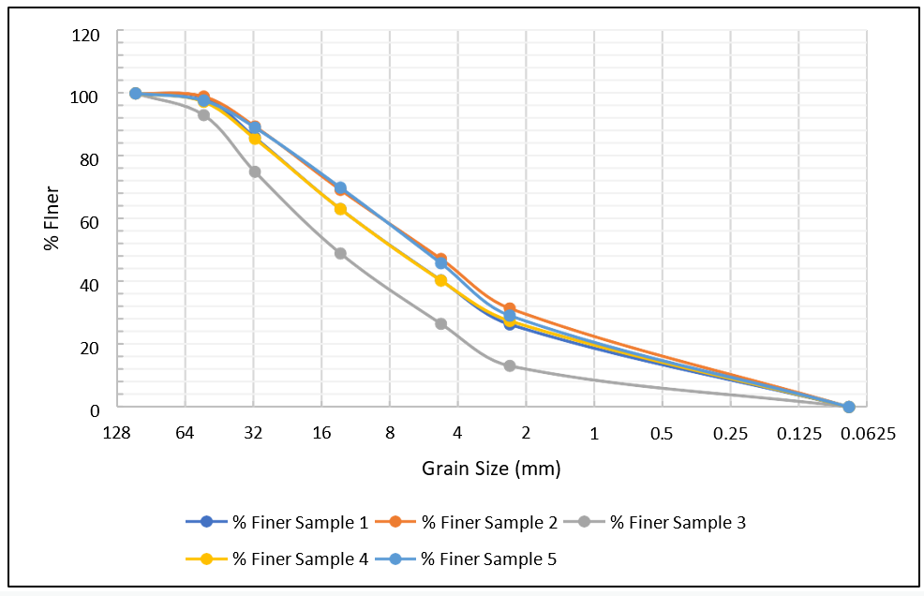
Figure 6. PSD analysis results and its influence on coal blending

Discussion and Research Contribution
This study provides quantitative evidence on the relative influence. Although the negative effects of TM and AC on GCV are generally known, this study also uses operational data and a simple regression-based framework. The primary contribution lies not in identifying the direction of the relationship—which is predictable—but in quantifying the sensitivity of GCV to TM and AC and translating this into actionable blending decisions. The results show that total moisture (TM) has a stronger and more consistent impact on GCV than ash content over the operational range studied. This finding suggests that moisture control should be prioritized in short-term quality management and blending strategies. Furthermore, the application of regression models to blending scenarios demonstrates how simple predictive tools can support decision-making without the need for complex optimization algorithms. However, this study has limitations. The relatively low R² value for ash content suggests that multi-parameter or nonlinear models could improve prediction accuracy. Future research could incorporate additional quality parameters, such as fixed carbon or volatiles, or explore machine learning-based approaches to improve prediction performance

CONCLUSION
This study developed and applied a linear regression-based model to predict the gross calorific value (GCV) of coal using total moisture content (TM) and ash content (AC) as the primary quality parameters. The results showed that both TM and AC exhibited a negative relationship with GCV; however, total moisture content exhibited a stronger and more consistent effect than ash content over the studied operational range. Quantitatively, a 1% increase (ar) in TM reduced GCV by approximately 104.82 kcal/kg (ar), while a similar increase in AC resulted in a smaller reduction of approximately 94.60 kcal/kg (ar). The higher coefficient of determination obtained for TM indicates that moisture content is the dominant variable governing short-term GCV fluctuations in coal blending operations. This finding highlights the importance of moisture content control as a key strategy in maintaining marketable coal quality. The application of the regression model to blending scenarios demonstrated its practical value for operational planning. The moderate and best-case blending configurations were able to maintain GCV within BA-48 specifications, striking a balance between quality compliance and efficient utilization of mine-grade coal. These results demonstrate that a simple prediction model can effectively support blending decision-making without the need for complex optimization techniques. From an industrial perspective, the proposed regression-based approach offers a practical and easy-to-implement tool for predicting GCV variation and managing quality risks in large-scale coal blending operations. Although the model is limited to linear behavior and two quality parameters, it provides a reliable basis for short-term quality prediction. Future studies are recommended to incorporate additional coal properties and explore multivariable or nonlinear modeling approaches to improve prediction accuracy and robustness.

REFERENCES
Anriani, T. (2013). Comparative Analysis of Te-67 Coal Quality at the Mining Front and Stockpile at the Air Laya Mine of PT. Bukit Asam (Persero), Tbk. Tanjung Enim, South Sumatra. Thesis, Faculty of Engineering: Sriwijaya University. Komariah, WE (2012). Improving the Quality of Low Rank Coal Through Moisture Removal with Microwave Heating.
Cahyadi. (2006). Strategy to Reduce Gas Emissions in Coal-Fired Power Plants that Do Not Have Desulfurization. Scientific Journal of Energy Technology, 1(2).
Government Regulation No. 42 of 1980 concerning State Capital Participation of the Republic of Indonesia. Muchjidin. (2006). Quality Control in the Coal Industry. ITB Publisher. Bandung.
Hana, M. (2005). Coal Quality and Stockpile Management. Yogyakarta: PT Geoservices. LTD.
Hardianti, Siti, and Yogi Saputra. (2018). Coal Blending to Meet Export Market Demand Criteria. Patra Akademika Engineering Journal Vol. 9, No. 1.
Jurnal Sainstek STT Pekanbaru. 4(1), 18–26.
K Oraee, N. Oraee, A. Goodarzi, and P. Khajehpour, (2016). “Effect of discontinuities characteristics on coal mine stability and sustainability: A rock fall prediction approach,” Int. J. Min. Sci. Technol., vol. 26, no. 1, pp. 65–70.
Mutasim, B. (2007). Increasing the Calorific Value of Low Rank Coal Using Kerosene and Residual Oil. Surabaya: UPN Press.
Nurisman, E and Saputro, D. (2014). Analysis of Coal Demand Fulfillment Planning Reviewed from the Aspects of Quality and Quantity in the Domestic Market at PT. Bukit Asam (Persero), Tbk. Tanjung Enim. Patra Akademika Journal, 2(10).
Nurrosyidi, Alditiya, Solihin, and Sri Widayati. (2023). Optimization of Coal Blending in an Effort to Improve Quality at PT. Bukit Asam, Tbk. Tanjung Enim, South Sumatra. Bandung Conference Series: Mining Engineering. Faculty of Engineering, Mining Engineering Study Program, Bandung Islamic University.
Pahlevi, R, et al. (2024). The Future of Coal Utilization as an Energy Source in Indonesia. JEBT: Journal of New & Renewable Energy. Defense University.
Prasetyo, AG, Triantoro, A., Saismana, U. (2016). Coal Blending Optimization Through Simulation Based on Coal Parameter Criteria. Himasapta Journal, 1(1), 11 – 16.
Purnamasari, Y. (2000). Making Briquettes from Low Quality Coal Using a Non-Carbonization Process by Adding MgO and MgCl2. Thesis, Faculty of Engineering: National Development University “Veteran” East Java.
Qibran, MF (2024). Coal Blending Analysis to Meet the Target Market of the BA-50 Brand of PT Bukit Asam Tbk Tanjung Enim, South Sumatra. Undergraduate Thesis, Sriwijaya University.
Sepfitrah. (2016). Proximate Analysis of Mining Results in Riau (Case Study of Logas, Selensen and Pangkalan Lesung).
Setiawan, A., Wibowo, AP, & Rosyid, FA (2020). Analysis of the influence of coal exports and consumption on Indonesia's economic growth. Journal of Mineral and Coal Technology, 16(2), 109-124.
Sloss, L.L., (2014). Blending of coals to meet power stations requirements. London: IEA Clean Coal Centre.
Sukandarrumidi (2009) Coal and Utilization. Gajah Mada University: Yogyakarta.
Suparny, Eny. (2016). Study of Optimizing the Blending of Different Quality Coal to Meet Consumer Demand at PT Berau Coal, Berau Regency, East Kalimantan Province.
Syarifudin. (2024). Coal Blending Course Materials. Sriwijaya University.
Syurdilah, D. (2017). Evaluation of the Causes of Unachieved Coal Blending Quality in West Banko PT. Bukit Asam (Persero) Tbk. Tanjung Enim South Sumatra. Thesis, Faculty of Engineering: Sriwijaya University.
Thesis. Jakarta: University of Indonesia.
Thomas, L. 2020. Coal geology. John Wiley & Sons Ltd.
Ubaidillah Anwar, Taufik Arief. (2011). Mathematical Model for Optimizing the Calorific Value of Blended Coal at PT Batubara Bukit Kendi Tanjung Enim, South Sumatra. AvoER National Seminar Journal. ISBN: 979-587- 395-4.
Wardani. (2008). Utilization of Coal Waste (Fly Ash) for Soil Stabilization and Other Civil Engineering Needs to Reduce Environmental Pollution. Diponegoro University.

